Create user

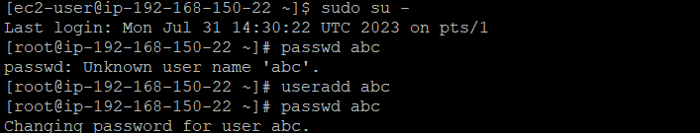

Give admin access,swith user and create a new user

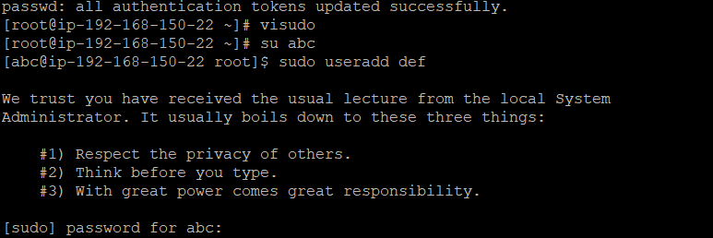

Find directory path “network-scripts” and find .gz files. create 5 files

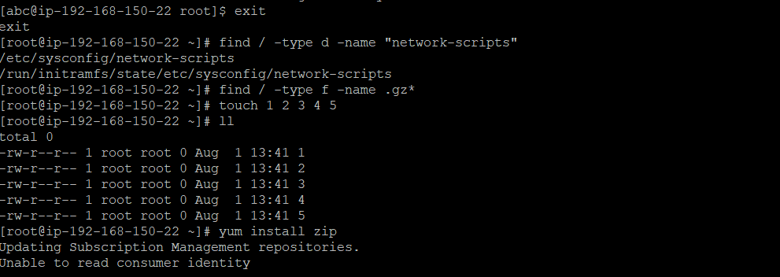

Zip files to backup.zip

